Study questions
Chapter 1
Describe the mind/body question.
Compare dualism and monism.
Discuss evidence that suggests consciousness is a physiological function.
Describe at least one study that suggests that unilateral neglect patients are not simply blind.
What do the behaviors of individuals who have had the “split-brain” operation tell us about brain function?
What is the split brain operation?
The 2 cerebral hemispheres have different abilities, discuss.
What are the 2 major symptoms of unilateral neglect?
What areas of the brain are damaged in unilateral neglect?
Describe the functions of the parietal lobes.
What is the Homunculus?
What is the ultimate function of the nervous system?
Describe the major contributions of Hippocrates, Descartes, Galvani, Muller, Flourens, Broca, Gustav Fritsch & Eduard Hitzig, Hermann von Helmholtz, and Darwin.
Describe natural selection and evolution.
Discuss a role that mutations play in the process of natural selection.
Explain the typical significance of a genetic mutation for an organism.
Give examples of structural and behavioral characteristics that might confer selective advantages to an organism.
Briefly describe the evolution of the human brain.

Chapter 2.
What are the different types of duplication errors?
Describe replication of chromosomes.
Describe the types of protection of the brain.
Describe the basic structures of the neuron.
Draw an action potential as seen on an oscilloscope. Describe the flow of ions during the action potential.
Discuss the forces that act on the membrane to maintain the resting membrane potential.
Describe the ions that maintain the resting membrane potential.
Explain the general function of the 3 glial cell types in the brain.
Explain what is meant by decremental conduction.
Explain how the presence of myelin on an axon speeds up conduction velocity.
Explain how autoreceptors dampen neural activity.
Explain how changes in ion movements can result in an action potential.
Describe ways in which NTs can cause EPSPs or IPSPs
Explain the importance of Ca2+ in neural transmission.
What would happen if the membrane permeability to Na increased?

Chapter 3.
Know the directions of the NS.
Briefly describe the development of the NS.
Know the following…we covered in detail the telencephalon and diencephalon.
Describe the function(s) of all structures of the brain (covered in class/text).
Describe the function of the spinal cord, describe the composition of the spinal cord, what protects it?
Describe the primary components of the spinal cord.
Compare the autonomic and somatic nervous systems.
Contrast the parasympathetic and sympathetic nervous systems. Describe 3 actions of the parasympathetic NS and 3 actions of the sympathetic NS.
Make sure you can label brain areas in figures from the text.

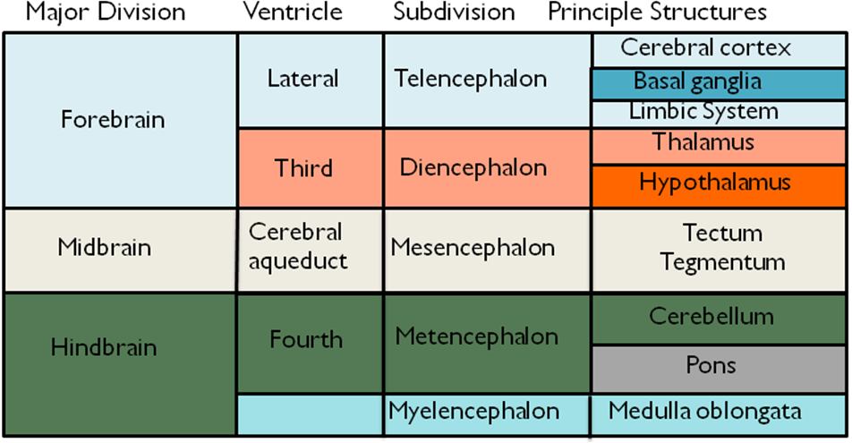

Describe the function of the radial glia and C-R cells during neural development.
Define the three major sections of the human brain.
Describe the features that function to protect the brain from external injury.
Describe the production, circulation, and re-absorption of CSF.
Explain the significance of the process of apoptosis for brain development.
Explain the distinction between primary motor cortex, sensory cortex, and association cortex.
Describe the structures that comprise the limbic system and briefly discuss the function of this system.
Describe the structures that comprise the basal ganglia and briefly discuss the function of this system.
Describe the general functions of the hypothalamus and thalamus.

Describe all terms in the text, as well as:
blindsight, phamtom limb, split brain, unilateral neglect, capgras syndrome, corpus collousm, cerebral hemispheres, Commissurotomy, mirror box, generalization, reduction, Functionalism, Natural Selection, Mutations, Selective Advantage, Neoteny, genes, chromosomes, alleles, genotype, phenotype, meiosis, mitosis, sex-linked traits, structural genes, operator genes, central nervous system, peripheral nervous system, meninges, sensory neuron, motor neuron, interneuron, soma, dendrite, axon, terminal button, synapse, neurotransmitter, buttons, axon hillock, myelin, multipolar neuron, unipolar neuron, bipolar neuron, membrane, cytoplasm, mitochondria, Endoplasmic Reticulum – rough and smooth, Golgi Apparatus, exocytosis, Lysosomes, Cytoskeleton, Microtubule, Axoplasmic Transport – anterograde and retrograde, Astrocytes, Oligodendrocytes, Microglia, phagocytosis, Lactate, nodes of Ranvier, Schwann Cells, The Blood-Brain Barrier, Area Postrema, membrane potential, resting membrane potential, depolarization, hyperpolarization, action potential, threshold of excitation, diffusion, electrostatic force, sodium-potassium transporter, all or none law, cable property, rate law, salutatory conduction, synaptic transmission, postsynaptic potential – EPSP and IPSP, axodendritic synapses, axosomatic synapses, axoaxonic synapses, Dendritic Spine, presynaptic Membrane, Postsynaptic Membrane, Synaptic cleft, postsynaptic density, terminal button, fusion pore, Postsynaptic receptor, Neurotransmitter-dependent ion channel, ionotropic receptor, Metabotropic Receptor, Reuptake, Enzymatic Deactivation, Neural Integration, Autoreceptors, Presynaptic Inhibition, Presynaptic Facilitation, gap Junction, Neuromodulators, neuropeptides, Hormones, Steroid, AChE, rostral, caudal, medial, lateral, ventral, dorsal, Cross Section or Frontal Section or coronal section, neuraxis, Horizontal Section, Sagittal Section, Midsagittal Plane, ventricles, Choroid Plexus, Lateral Ventricles, Third Ventricle, Cerebral Aqueduct, Fourth Ventricle, CSF, ectoderm, Neural Tube, Ventricular Zone (VZ), Progenitor Cells, Symmetrical Division, Asymmetrical Division, Radial glia, Cajal-Retzius (C-R) cells, Apoptosis, Sulci, Fissures, gyri. midbrain, tectum, tegmentum, mesencephalon, Tectum, superior colliculi, inferior colliculi, reticular formation, periaqueductal gray matter, red nucleus, substantia nigra, VTA, Hindbrain, Metencephalon, Cerebellum, Pons, Myelencephalon, Medulla oblongata, Spinal Cord, Somatic Nervous System, The Autonomic Nervous System, spinal nerves, afferent, efferent

