Study Questions
Chapter 11
Discuss the imaging experiments that implement the amygdala in emotion processing.
Discuss the role of the amygdala in processing facial expressions of fear (describe specific experiments).
Describe patient SM, what problems did she have in processing fear?
Describe the neural circuitry in defensive behaviors.
Discuss the role of 5-HT in aggressive behaviors (in both animals and humans). Please use specific examples of experiments.
What is the function of the vmPFC (use specific examples).
Describe the role of hormones in aggressive behavior (animals and humans) – use specific examples of experiments.
Describe the role of the MPA in aggressive behaviors.
Describe aggressive behaviors in females (both animals and humans - use specific examples).
What are the six basic facial expressions, why are they considered “universal”?
Describe the findings of Paul Ekman,
Discuss laterality and emotional recognition – use specific examples.
Discuss the role of the amygdala in emotion recognition.
Describe the effects of lesions to the amygdala have on processing facial expressions of fear. Why the specific problem with fearful expressions? How was it resolved?
Why is it important to identify direction of gaze? Where in the brain does this function sit?
What are mirror neurons, what role do they play in emotion processing?
What brain area mediates disgust? What is the evidence?

Describe the role of the anterior cingulated cortex in laughter.
Describe the role of the right vmPFC in humor.
Describe the evidence to suggest that emotion is lateralized.
Describe the the James-Lange Theory of emotion. Describe the evidence that supports this theory.

Chapter 13
Describe learning, memory.
Describe the different types of learning, where does the learning occur?
Describe how the pairing of a strong stimulus with a neutral stimulus (weak synapse) results in the strengthening of the neutral stimulus synapse.
What is the difference between fear conditioning and operant conditioning?
Why is operant conditioning considered flexible?
Describe the steps necessary to generate LTP. What are the molecular changes that occur in the presynaptic and postsynaptic cells? Where is it generated? How long does it last?
Describe the trisynaptic loop.
LTP requires 2 events, describe.
Describe the role of NMDA receptors in LTP
Describe the role of Ca in LTP.
What is the role of NMDA receptors in associative LTP?
What is responsible for the increase in synaptic strength that occurs during LTP?

Describe the events in this figure:
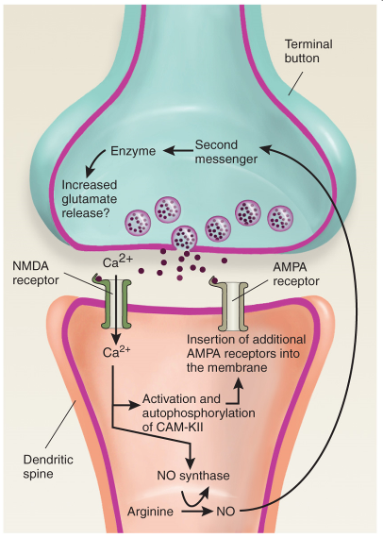
Compare LTP and LTD.
Describe NMDA-independent LTP.
Describe the “what” and the “where” pathway for visual recognition.
What is the role of the prefrontal cortex in short-term perceptual learning?
How do you generate a CER?
Describe the role of the LA in CER, what is the evidence for the involvement of lateral nucleus of the amygdala in CER?
Describe LTP in the amygdala following CER training.
Describe the major pathways in instrumental learning.
Describe the role of the basal ganglia in instrumental learning.
Describe the neural circuits involved in reinforcement.
Describe the connections of the basal ganglia.
What is the evidence that supports the role of the Basal Ganglia in instrumental learning?
Describe the role of the VTA and nucleus accumbens in reinforcement.
Describe the Dopaminergic Pathways in a Rat Brain.
What is the role of dopamine in reinforcement?
What is the role of the PFC in reinforcement?
Compare relational learning, perceptual learning, motor learning and stimulus-response learning.
Despite robust memory deficits, people with anterograde amnesia have spared learning abilities, discuss.
Describe specific tasks that test perceptual learning, stimulus-response learning, and motor learning.
Describe the role of the hippocampus in memory.
What is the difference between long-term and short-term memory?
How is information converted from short-term to long-term memory?
What are the major inputs and outputs to the hippocampus?
Describe the Role of the Hippocampal Formation in Consolidation of Declarative Memories.
The hippocampus role in memory is time-dependent, discuss.
What is the role of the hippocampus in spatial learning. Discuss the relevant research.
What is reconsolidation? Describe the role of the hippocampus in reconsolidation.
LTP is a model of learning, discuss.
What is the role of neurogenesis in learning?

Terms: amygdala, lateral nucleus of the amygdala, central nucleus of the amygdala, conditioned emotional response, extinction, Threat Behavior, Defensive Behavior, Submissive Behavior, Predation, aggressive behaviors, 5-HIAA, Ventromedial Prefrontal Cortex, Organizational effects, Activational effects, Medial Preoptic Area, vomeronasal organ, Affective Blindsight, superior temporal sulcus, mirror neurons, Anterior insulaVolitional Facial Paresis, Emotional Facial Paresis, Chimerical faces, perceptual learning, stimulus-response learning, classical conditioning, unconditional response, unconditional stimulus, conditional stimulus, conditional response, hebb rule, instrumental conditioning, reinforcing stimuli, punishing stimuli, motor learning, spatial learning, episodic learning, relational learning, LTP, LTD, hippocampus, dentate gyrus, CA1, CA2, CA3, subiculum, entorhinal cortex, perforant path, population EPSP, mossy fiber, schaffer collateral, associative long-term potentiation, nonassociative long-term potentiation, long-term depression, NMDA receptors, AP5, dendritic spike, AMPA Receptors, CaM-KII, Nitric Oxide Synthase, ventral stream, dorsal stream, short-term memory, delayed matching-to-sample task, basal ganglia, VTA, Nucleus Accumbens, Anterograde Amnesia, Retrograde Amnesia, Korsakoff’s syndrome, consolidation, reconsolidation, declarative memories, nondeclarative memories, perirhinal cortex, parahippocampal cortex, episodic and semantic memories, semantic dementia, spatial memory, Morris water maze, place cells,

