Mind and Brain Assignment
Introduction to Neuroanatomy and Digital Macroscopy

Histology and image analysis are important components of neuroscience research. Regardless of the species of interest, a working knowledge of neuroanatomy, staining techniques, microscope equipment and digital imaging and analysis software are important.

This assignment is designed to introduce you to:
- The concepts of histological analysis
- The principles of digital imaging techniques in the neurosciences
- The practical knowledge of brain structures and directional vocabulary
- The stereotaxic coordinates of brain structures in the rat

Required items:
- Digital camera and lens
- Suitable light source
- Paxinos and Watson stereotaxic atlas (a copy is available in SN-3097)
- Microscope slides of stained brain sections
- A flash drive for digital storage of images

Instructions:
- We have a sign-up sheet for you to book time in the Imaging Lab. You can sign up in groups of 4. There is limited time available due to the activity of the lab, so please ensure that you do not miss your scheduled time.
- When you are in the lab (SN-3097), an assistant will help you acquire the digital images of your rat brain tissue.
- Once you have your digital images, consult the Paxinos and Watson stereotaxic atlas, your textbook and the assistant to help you complete Part 1 of the assignment.

Part 1: Rat Brain Images (5%)
The 5 brain sections on the slide you photographed were arranged out of order (they do not correctly match the anterior-posterior stereotaxic coordinates). You are to import the digital images onto a page and arrange them in the correct anterior-posterior order (the most anterior section first). Using the Paxinos and Watson Rat Brain Atlas, provide the correct corresponding stereotaxic coordinate in reference to bregma. You may need to re-size the images to fit them on the page. You can try putting them all on the same page but 2 images per page is probably better.

In your sections identify the following structures:
Hippocampus (Dentate Gyrus - DG, CA1 and CA3) Corpus Callosum (CC)
Striatum (Caudate Putamen; CPu) cingulate cortex (ACg)
Amygdala (Central and Basolateral nuclei; Ce, BL) medial preoptic area (MPO)
Thalamus (anterodorsal nucleus; AD) periacqueductal gray (CG)
Hypothalamus (ventromedial; VMH) lateral ventricles (LV)
Your page should look something like this:
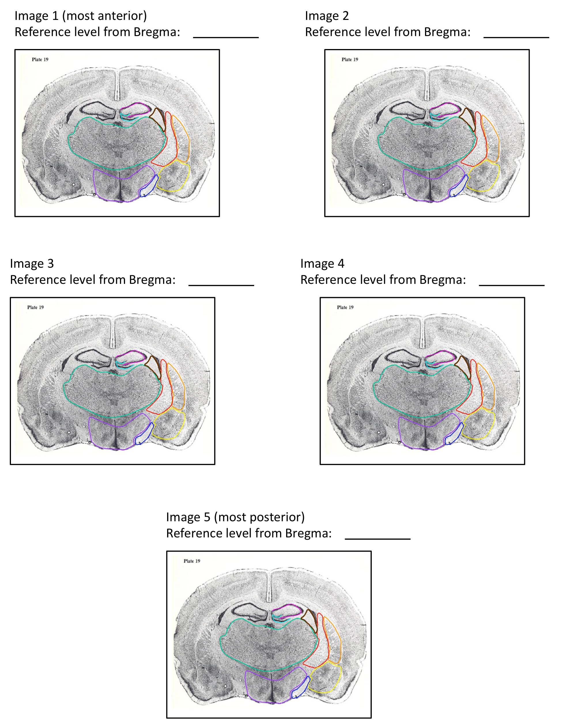

Part 2: Literature Search (5%)

In the second part of the assignment you will find a research article (not a review paper) that examined the function of one of the areas listed above. Ideally the article should combine neuroscience and behavioural techniques (i.e., an experiment where the amygdala was lesioned and the subjects were tested in a fear conditioning task). You are required to write a summary of the article (no more than two pages 2 pages; excluding the cover page and the reference page). Your summary should be typed using a 12-point font and double-spaced. Please include a cover page and number the pages of your assignment. You must also provide a Reference section at the end where you list (in APA format) the article(s) you cited.

Your assignments will be graded for content and grammar.

Due date: March 5th

